Name

Observing Mitosis Lab

Background:
In a growing plant root, the cells at the tip of the root are constantly dividing to allow the root to grow. Because each cell divides independently of the others, a root tip contains cells at different stages of the cell cycle. This makes a root tip an excellent tissue to study the stages of cell division. A blastula is an animal embryo at the early stage of development when it is a hollow ball of cells. For the same reasons as for the root tip, the blastula is also a good tissue to study the stages of cell division.

Materials:
microscope prepared slides of onion (allium) root tips or fish blastulas

Procedure:
- In groups of two, get one microscope for your lab group and carry it to your lab desk with two hands. Make sure that the low power objective is in position and that the diaphragm is open to the widest setting.

- Obtain a prepared slide of an onion root tip or fish blastula (there will be three samples on a slide). For the root tips, hold the slide up to the light to see the pointed ends of the root sections. This is the root tip where the cells were actively dividing. (The root tips were freshly sliced into thin sections, then preserved when the slide was prepared.)

- Place the slide on the microscope stage with the root tips pointing away from you. Use the low-power objective to find a root tip or blastula, and focus it with the coarse-adjust knob until it is clearly visible. Just above the root “cap” is a region that contains many new small cells. The larger cells were in the process of dividing when the slide was made. These are the cells that you will be observing. Center the image, then switch to high power.

Observe the box-like cells (root) or round cells (blastula) that are arranged in rows. The chromosomes of the cells have been stained to make them easily visible. Select one cell whose chromosomes are clearly visible. (If you need to change the focus when using high power, remember to only use the fine adjust!)
- Sketch the cell that you selected in the box on the right.

- Look around at the cells again. Select four other cells whose internal appearances are different from each other and the first one that you sketched. Sketch them in the boxes below.

- As you look at the cells of the root tip, you may notice that some cells seem to be empty inside (there is no dark nucleus or visible chromosomes). This is because these cells are three dimensional, but we are looking at just thin slices of them. (If you slice a hard-boiled egg at random, would you definitely see the yolk in your slice? No.) We want to continue to look at the cells, but we will ignore anywhere we cannot see the genetic material (dark areas).

- Looking along the cells you’ve drawn, identify what stage each cell is in and label it. Use the photos below as guide.

Interphase  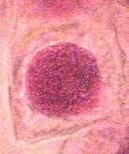 | Prophase  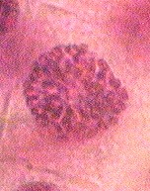 | Metaphase  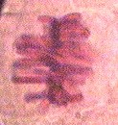 | Anaphase  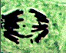  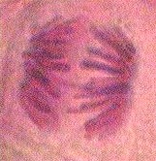 | Telophase  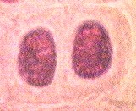
(dark mass) | (chromosomes | (chromosomes | (pulling | (two nuclei)
 | visible but | lining up | apart)
 | not organized) | along equator)

