Date: _________________ Name: _________________________
Science 9 Learning Targets for Reproduction
Chapter 4
Target # | Descriptor | Confident | Unsure
1 | Using cell diagrams, identify and provide a function for each of the following organelles:
1 | - cell membrane
1 | - cytoplasm
1 | - mitochondrion (plural = mitochondria)
1 | - ribosome
1 | - endoplasmic reticulum
1 | - vesicle
1 | - vacuole
1 | - Golgi body (or Golgi apparatus)
1 | - nucleus
1 | - nucleolus
1 | - nuclear membrane (or nuclear envelope)
 | - nuclear pore
 | - chloroplasts
 | - cell wall
2 | Identify and be able to describe the following contents of the nucleus:
2 | - deoxyribonucleic acid (DNA)
2 | - genes
2 | - chromatin
2 | - chromosomes
3 | Describe the structural arrangement of DNA in regards to the following terminology:
 | - double helix
 | - sugar-phosphate backbones
 | - complementary base-pairing (cytosine with guanine, and thymine with adenine)
4 | Understand the basic relationship between genes and proteins (i.e., genes code for proteins).
5 | Recognize the three basic types of gene mutations, and understand the consequences of mutations in general (positive, negative or neutral):
5 | - base deletion
5 | - base addition
5 | - base substitution
6 | Identify factors (mutagens) that may lead to changes in a cell’s genetic information.

4.1 The Function of the Nucleus within the Cell
Animal Cells
Animal cells are equipped with many _____________________ that allow the cell to perform a variety of ____________________________.
What to Do: Label each cell part.

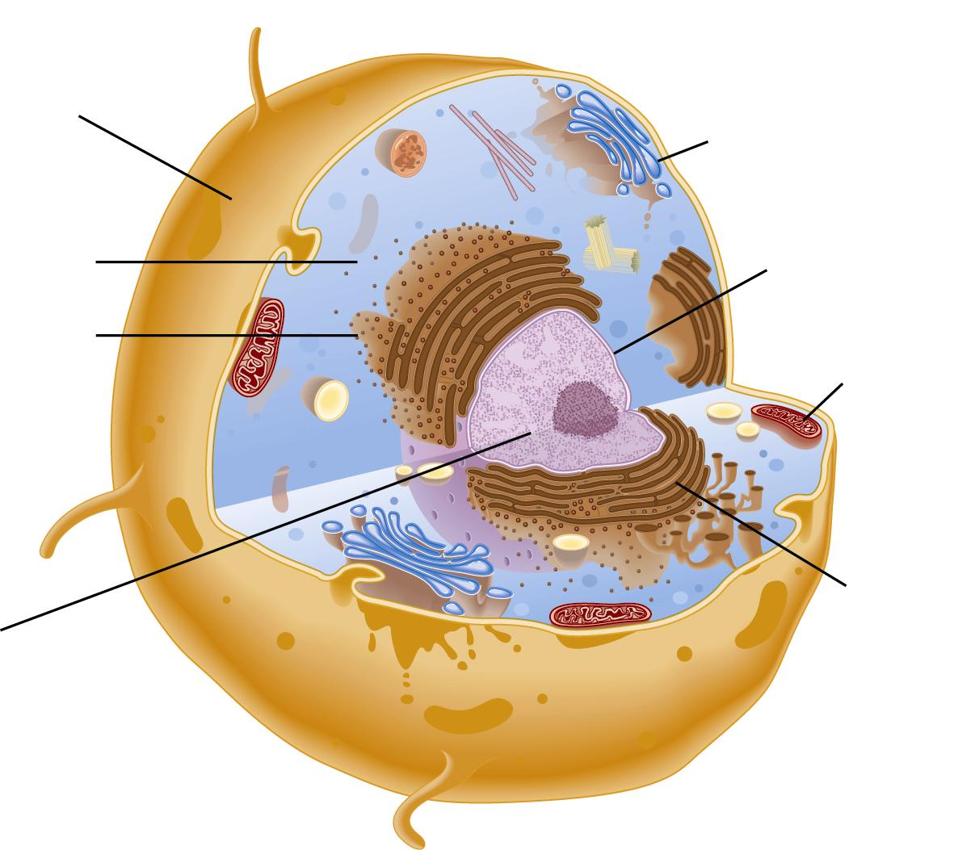

Plant Cells
Plant cells are equipped with some structures that animal cells __________________ have.

What to Do: Label each cell part.

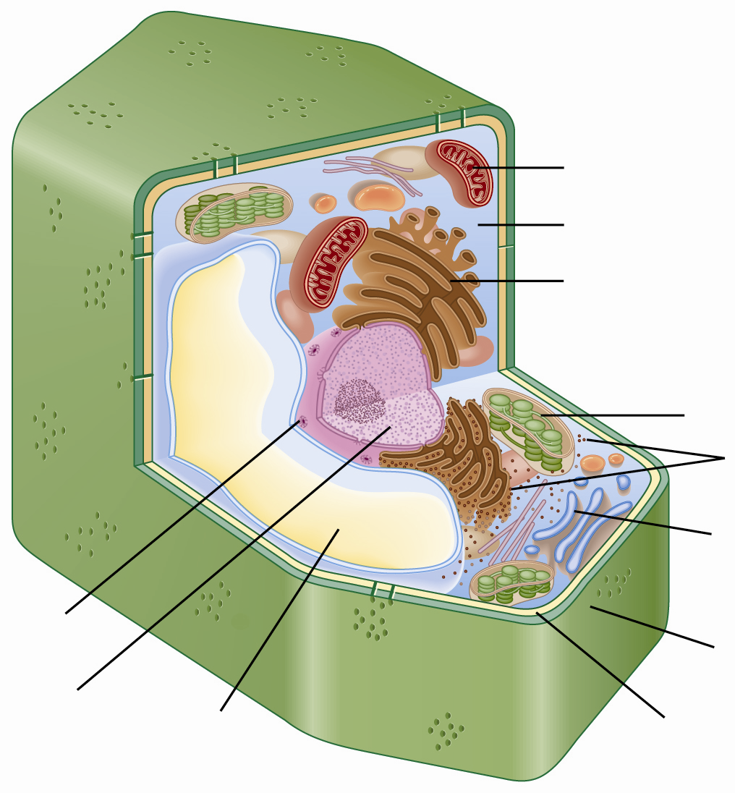

Cell Parts and Organelles
1. Complete the left hand column of the chart on cell organelle functions from the notes PowerPoint.

2. On the right column, compare your cell to something like a city, a factory, a company, a human body, a school, etc. Each cell part has a role in the cell similar to the parts of any of the above.

Cell Organelle | Functions
Cell Organelle | Membrane |  | Cell | _______________________
Cell membrane
Cytoplasm
Mitochondria
Ribosomes
Endoplasmic reticulum
Vesicles
Golgi body
Cell Organelle | Functions
Cell Organelle | Membrane | Cell |  | _______________________
Nucleus
Nucleolus
Nuclear membrane
Nuclear Pores
Vacuoles
Chloroplasts
Cell Wall

*Large Vacuoles:

HOMEWORK: ____________________________________________________________

The Nucleus and DNA
- The nucleus contains DNA (______________________________________________________);
DNA is the molecule has the master set of _____________________________ for
how cells ____________________, what they will _____________________, and when they will _________.
Structure of DNA
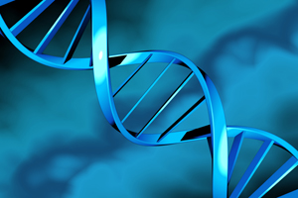
- DNA looks like a _______________________ - two strands
wrap around each other in a ____________________ shape.
- The sides of the DNA ladder are made of
____________________ and ______________________.
- The steps of the ladder are made of four
nitrogen bases:
(A) | (G) | (C) | (T)

- The bases join in a specific way: ______ always joins with _______
_______ always joins with _______
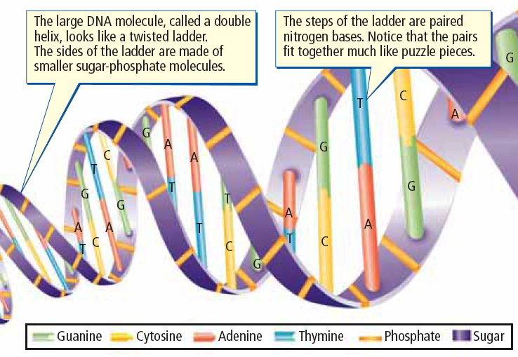
Sugar + Phosphate + Nitrogen base =
__________________________

DNA in the Nucleus
- Most of the time DNA is in the form of ____________________
- Chromatin coils tightly into X-shaped ______________________________ when it’s time for the cell to divide.
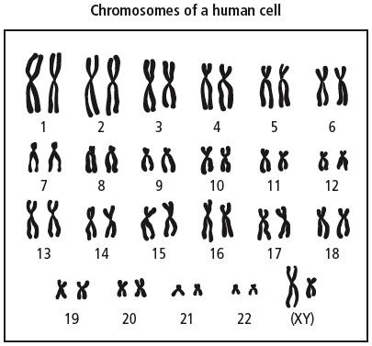
- Every organism has a specific
________________ of chromosomes
- Human cells have ____________
chromosomes arranged in
___________ pairs
- The 23rd pair determines _________;
  - _________ for females
  - _________ for males

Drawing of DNA à Chromatin à Chromosomes

Goal • Use these models of the parts of DNA to visualize the alpha helix.

What to Do
IN PAIRS: Develop your own model of DNA. Follow the instructions below.

- The completed model should look like a ladder. Matched bases form the rungs. Besides being shaped like a ladder, a real DNA molecule is twisted like a spiral staircase (alpha helix).
Materials
- paper models
- scissors
Safety
Be careful when handling sharp or pointed objects.

Procedure
1. Cut out the nucleotide models. Cut only on solid lines.

2. Fit eight nucleotide molecules together in puzzle-like fashion in any order to form a row.

3. The above arrangement represents the left half of the ladder of DNA. Complete the right side of the DNA ladder by matching the shapes of the rungs. It may be necessary to turn molecules upside down in order to join certain base combinations.

4. Come show me your finished DNA molecule.

HOMEWORK: ____________________________________________________________

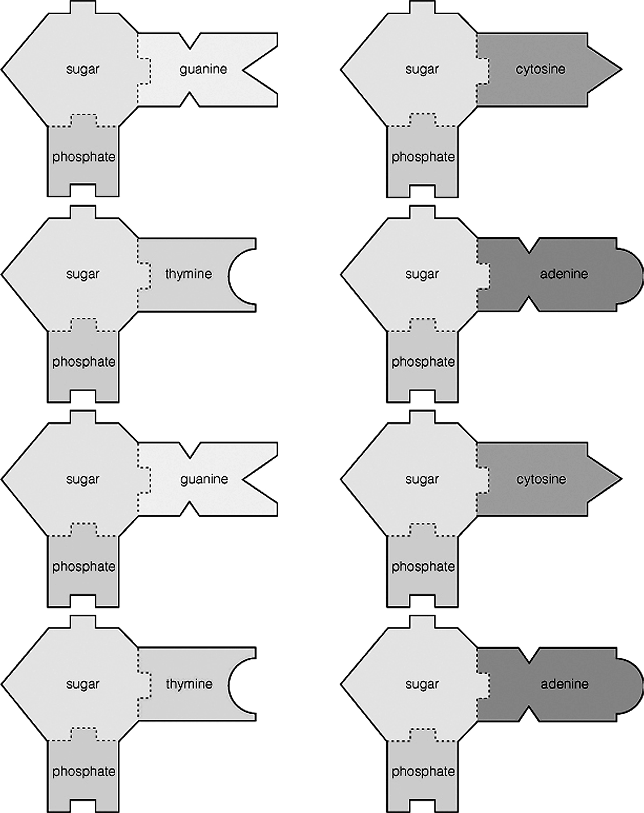

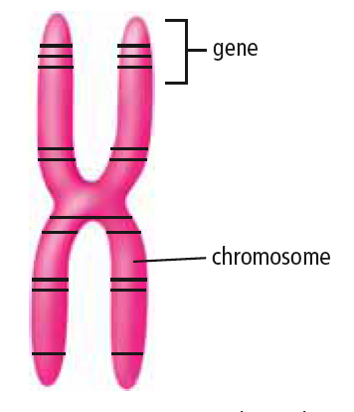
Genes
- Genes are small segments of __________
located on a _______________________
- Genes store the information needed
to produce ________________________
- Each chromosome can carry
___________________________ of genes
- All your body cells have the ____________ genes,
but only specific genes are “______________” in
each cell to produce specific ________________
  - E.g. _________________________
- Specialized proteins called ______________ and
_______________________ carry out important specific functions in the body.
Production of Proteins
- _____________ production in the cell involves several important steps (E.g. _______________):
- The __________________ receives a chemical ______________ to make a specific protein.
- The DNA message (_________) for the protein is copied into a small molecule called _______.
- RNA leaves the nucleus through a __________________ _____________.
- The RNA message is delivered to a __________________ , the ribosome makes the protein.
- The manufactured protein enters the _______________________ ________________ (ER).
- A ______________ forms at the end of the ER, and carries the protein to the _________ body.
- The Golgi body _______________________ the protein for ________________ out of the cell.
- A vesicle forms off the end of the Golgi body to carry the protein to the cell _______________.
- The vesicle attaches to the cell membrane, and its protein contents are released out of the cell.

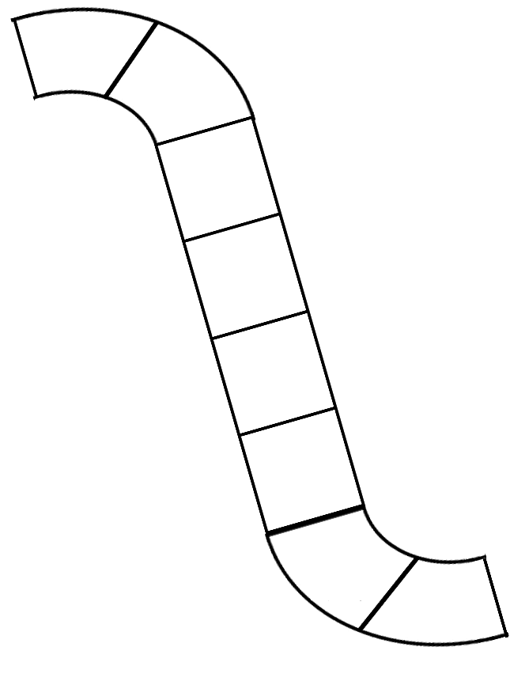
HOMEWORK: ____________________________________________________________
Types of Mutations
- A ______________ mutation involves a __________________ in the order of bases (A,C,T,G) that make up the gene. There are several types of gene mutation:
  - ___________________ (base missing)
  - ___________________ (extra base added)
  - ___________________ (one base substituted for another)

Effects of Mutations
- _________________ Mutations
  - When a gene mutation produces proteins that benefit the individual.
  - Example: Some plants have developed resistance to bacterial and fungal infections.
- _________________ Mutations
  - When a gene mutation produces proteins that harm the individual
  - Example: Sickle cell genes in affected humans cause blood cells that are abnormally shaped.
- _________________Mutations
  - When a gene mutation produces proteins that have no effect on the individual
  - Example: a particular mutated gene produces white coat Kermode bears (Spirit Bears).
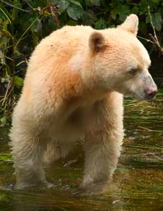
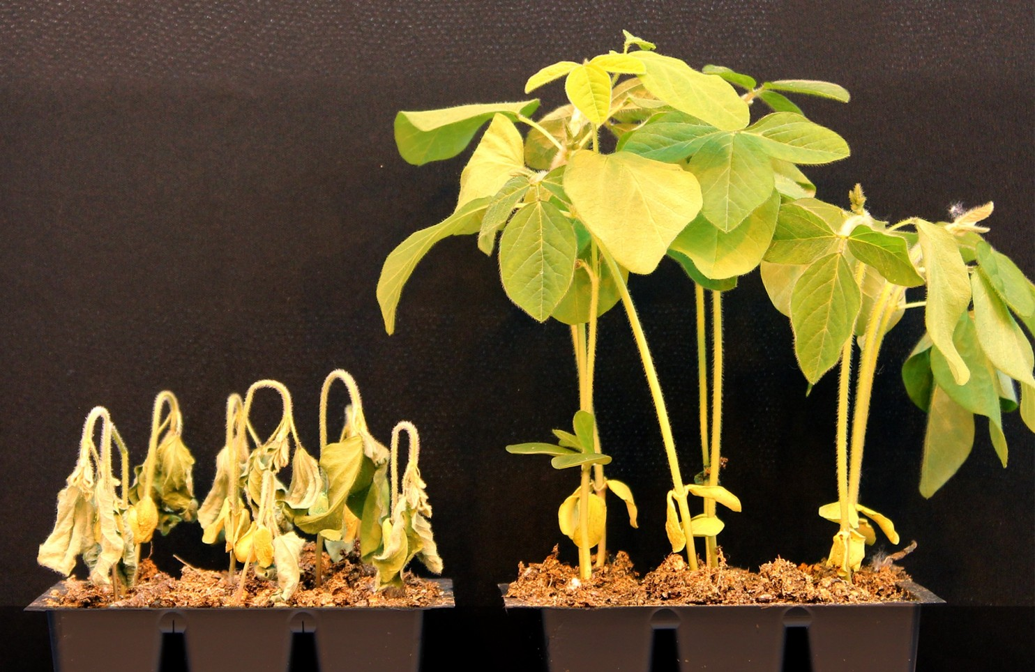
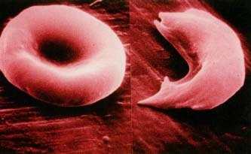

ACTIVITY: Identifying Mutations:
The Spirit Bear is white because of a genetic mutation. The sequence of DNA in a gene is interpreted in groups of three bases. In the Spirit Bear, the sequence of bases for white coat colour is different than that of the black coat colour. Since the DNA sequence is interpreted in groups of three bases, a substitution, loss, or addition of a base will change the meaning of a DNA message. In this activity you will learn how these three types of gene mutations affect the proteins that are made in a cell.
What to do:
- To explain gene mutations, scientists compare the genetic code to that of a sentence.
- Write a sentence below that has only three letter words in it and is 7 words long.
Your sentence here:

Now re-write your sentence without spaces:

- Now re-write you sentence substituting any one letter for another and add spaces:

- Now re-write your sentence deleting any one letter from the entire sentence and add spaces:

- Now re-write your sentence adding one letter at any place in the sentence and add spaces:

What did you find out:
- When was your sentence still understandable? When was it not?

- Compare your sentences to the genetic code. How are these types of typos related to genetic mutations?

- What types of gene mutations may be the least damaging for the cell? Why?

- What types of gene mutations may be the most damaging for a cell? Why?

HOMEWORK: ____________________________________________________________

4.2 Mutation
Mutagens
- Mutations can occur when DNA is being made or can be caused by _________________________.
- Mutagens are substances or ___________________ that cause ____________________________.
- Environmental mutagens such as: ____________________________________________________
________________________________________________________________________________
and certain viruses can cause mutations.
VIDEO: How does smoking cause cancer?

Mutation Repair
- Correcting mutations is difficult, but new techniques such as ____________ __________________ offer hope.
- Gene therapy is complicated and experimental:
  - A virus is engineered to carry a ____________________ gene
  - The virus must somehow be _________________________ to the cells with the defective gene
  - The normal gene must then ______________________ the defective gene
  - The normal gene must then be “____________________________” so that the replacement normal gene produces the proper healthy proteins. It is also important that the normal gene make the correct _______________________of healthy protein.
VIDEO: Will Gene Therapy Cure Cancer?

Reflection Question #1: If we are able to use gene therapy to cure or fight diseases, should we be able to determine/change what our children’s traits are going to be? (E.g. eye colour, gender, etc.)

Reflection Question #2: If you were a gene hacker, what crazy genetic mutation would you give yourself? Why?

