








P16-27

What is MATTER?

Anything that has __________ (g)

and ______(L)

- Mass is ____________________________

- Volume _______________________________________



Matter can undergo 2
types of changes:

Physical Changes
- Chemical Changes
Physical Change – may change in appearance but________________________ is formed.

What are the three states of matter?



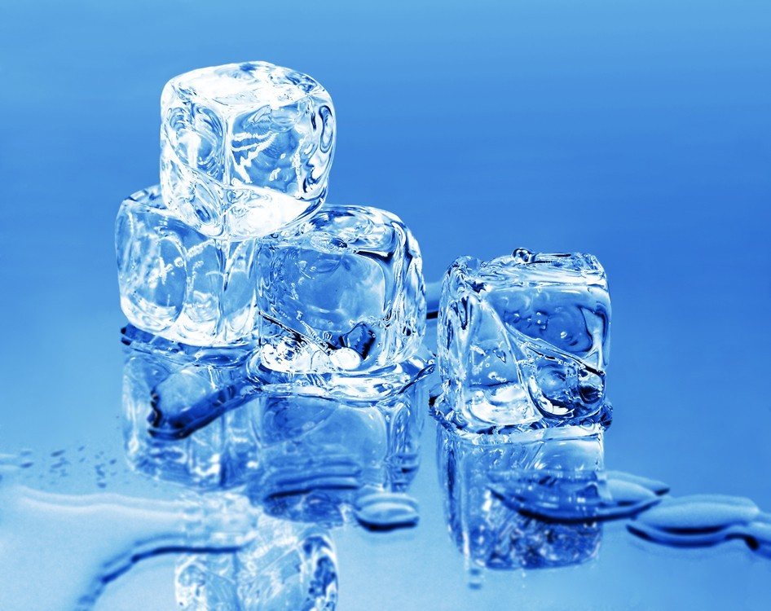

States of Matter w.youtube.com/watch?v=s-KvoVzukHo
http://ww

What is a chemical change?

a change in matter that occurs when substances combine to _____________________________________.
  - Example: Fireworks

Hint: production of a _______________________ is a sign that a chemical change has occurred

Bag of Change Lab

Text p. 17 – Read Safety, Materials and What to do before we begin.
- Have your pre-lab signed BEFORE gathering materials
- Record all observations on your lab data sheet provided
- Be sure to clean up your entire lab area.

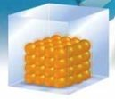
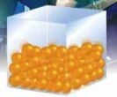
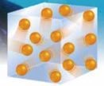
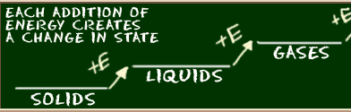
What is the Kinetic Molecular Model?

Describes what happens to matter when the __________________________ of particles changes.
The main points in the theory are:
- Matter is made of _______________ 2.There is ______________________ between particles
3. Particles are __________________

_________ particles are packed together and
cannot move freely. They can only vibrate

  - _________ particles are farther apart and can slide past each other

  - _________ particles are far apart and move around quickly
- __________________ makes particles move

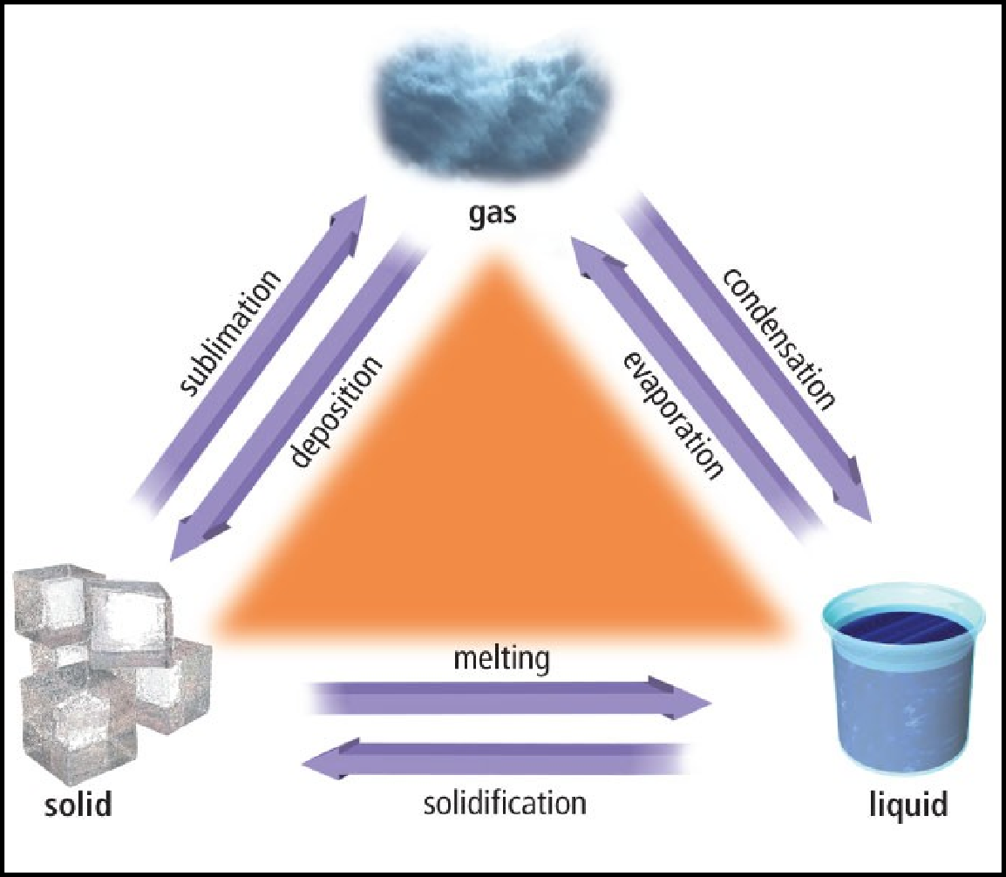
Changes of State

Describe the changes of state in your own words:
melting
evaporation
deposition
solidification
condensation
sublimation

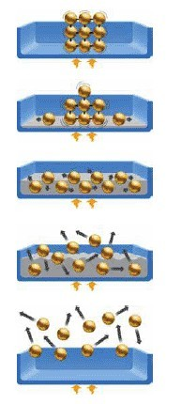

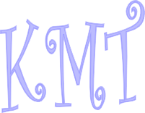













http://www.bbc.co.uk/schools/ks3bitesize/science/chemical_material_behaviour/behaviour_of_matter/activity.shtml

Solid
Particles are close together, fixed in position and vibrating

Melting
As ______________________ increases, particles’ kinetic energy increases

Liquid
Particles are still close, but _______ past one another.

Boiling
As temperature increases, particles’ kinetic energy continues to increase, creating more __________.

Gas
Particles are highly energetic and moving freely.

VIDEO ACTIVITY
+Page 22

Physical Properties characteristics that can be observed or measured

Qualitative Properties
Can be described, not measured
Quantitative Properties Can be measured using numbers

Pure Substances

Element - a pure substance that cannot be __________________ or separated into simpler substances (e.g., gold)

  - Compound - a pure substance composed of at least two _________________ (e.g., water)

